

**NAME**: Syed Naqi Haider

**ID**  : F2017065126

**COURSE:** DATA SCIENCE TECHNOLOGIES

**SUBJECT**: PROJECT DOCUMENTATION

**TO**  : MAZHAR JAVED AWAN

**PROJECT DOCUMENTATION**

The Data set which used is Sindh-School-Enrollment-Stats after seen it with quite detail and try to find the best usefull data from It I have decided to use it to predicte the number of teacher required for a gaven amount of students and institution. I have tried to explain the working and did my best to perform all the task.

import pandas as pd

import matplotlib.pyplot as plt

import seaborn as sns

import numpy as np # all the required libaries are Imported for working

df = pd.read_csv('Downloads//sindh-school-enrollment-stats.csv')# 1 panda function used

df.head()

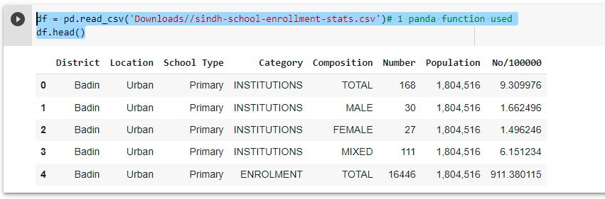

Now We start cleaning and removing all the data which is not requried for prediction .

df1 = df.drop(['Population', 'No/100000'], axis=1)#2 function is used of  panda

df1.head()

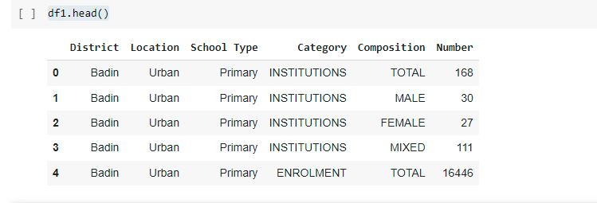

A_filter = (df1['Category'] == 'INSTITUTIONS') & (df1['Composition'] == 'TOTAL')

df2 = df1[A_filter]

s=np. arange(348)#1 numpy function used

df2.set_index(s, inplace=True)

A_filter = (df1['Category'] == 'TEACHING STAFF') & (df1['Composition'] == 'TOTAL')

df3 = df1[A_filter]

df3.set_index(s, inplace=True)

A_filter = (df1['Category'] == 'ENROLMENT') & (df1['Composition'] == 'TOTAL')

df4 = df1[A_filter]

df4.set_index(s, inplace=True)

df5 = df1.drop(['Category', 'Composition', 'Number','School Type'], axis=1)

print(df5.head())

df5['INSTITUTION'] = df2['Number']

df5['TEACHING'] = df3['Number']

df5['ENROLLMENTS'] = df4['Number']

#droping columns and adding the required onces

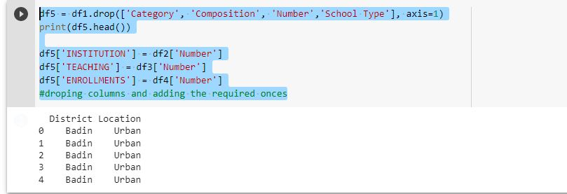

df5.head()

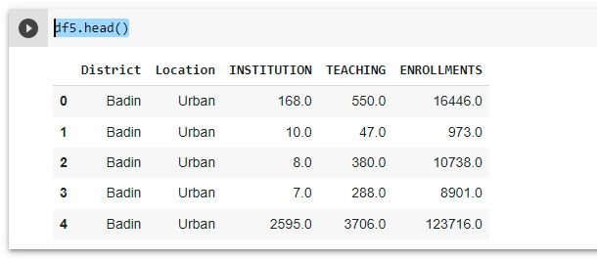

df6=df5.dropna(how='any')# final datafram which is going to be used to apply the graphics and models

df6.head()

Matplotlib

xaxis=df6['INSTITUTION']

yaxis=df6['ENROLLMENTS']

plt.plot(yaxis, xaxis)

plt.show()

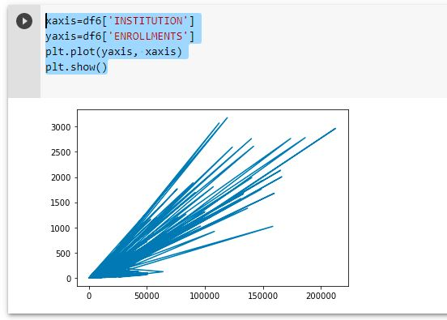

plt.xlabel('Institution')

plt.ylabel('ENROLLMENTS')

plt.scatter(df6.INSTITUTION, df6.ENROLLMENTS, color='red', marker='+')

plt.show()

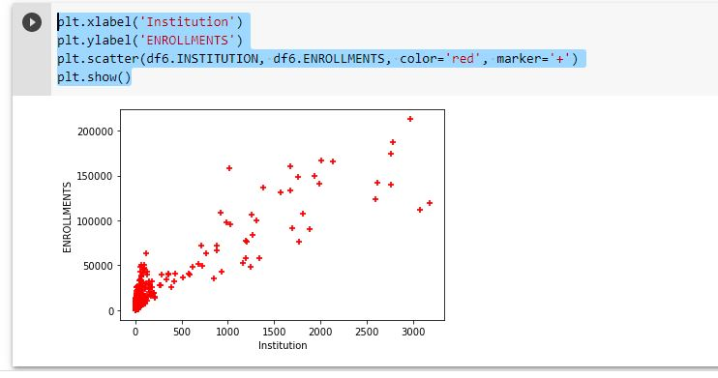

y = df6['TEACHING'].sum()

x= df6['ENROLLMENTS'].sum()

z= df6['INSTITUTION'].sum()

t=np.array([y,x,z])#numpy second function is used

mylabels = ["INSTITUTION", "ENROLLMENTS", "TEACHER",]

plt.pie(t,labels=mylabels)

plt.show()

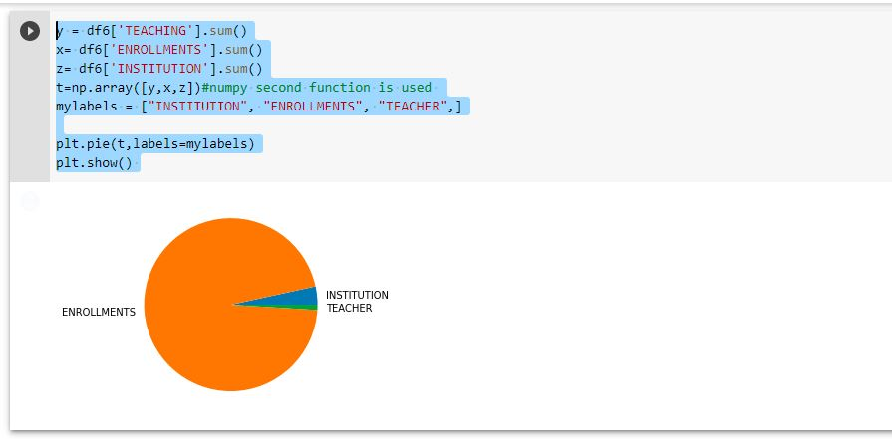

y = df6['TEACHING'].sum()

x= df6['ENROLLMENTS'].sum()

z= df6['INSTITUTION'].sum()

t=np.array([y,x,z])

plt.hist(t)

plt.show()

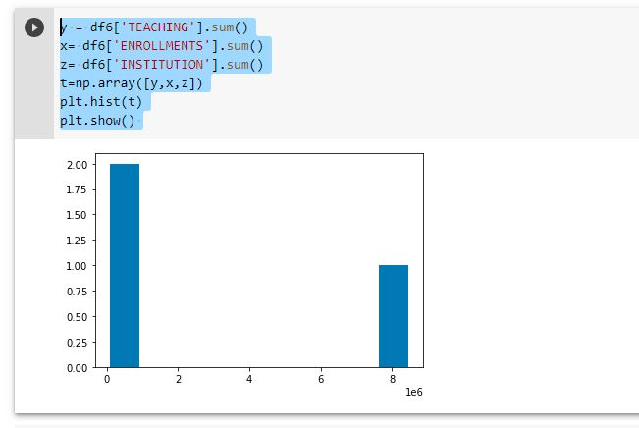

mean=np.mean(y)#3 Function of numpy

y

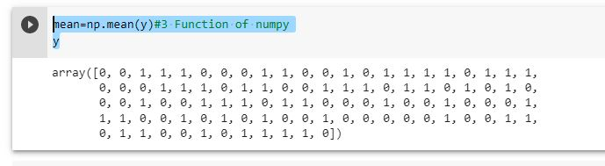

y = df6['TEACHING'].sum()

x= df6['ENROLLMENTS'].sum()

z= df6['INSTITUTION'].sum()

t=np.array([y,x,z])#numpy second function is used

mylabels = ["INSTITUTION", "ENROLLMENTS", "TEACHER",]

plt.barh(mylabels, t,color = "#4CAF50")

plt.show()

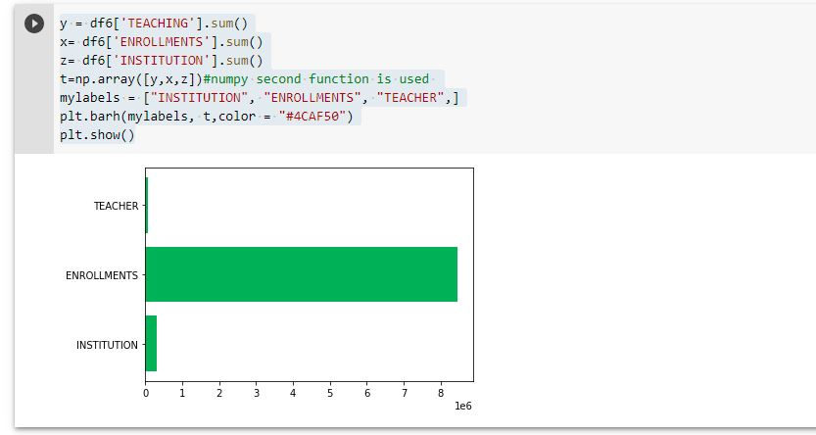

# SEABORN

sns.pairplot(df6)#this has 9 and 2 are more gaven so it makes 11

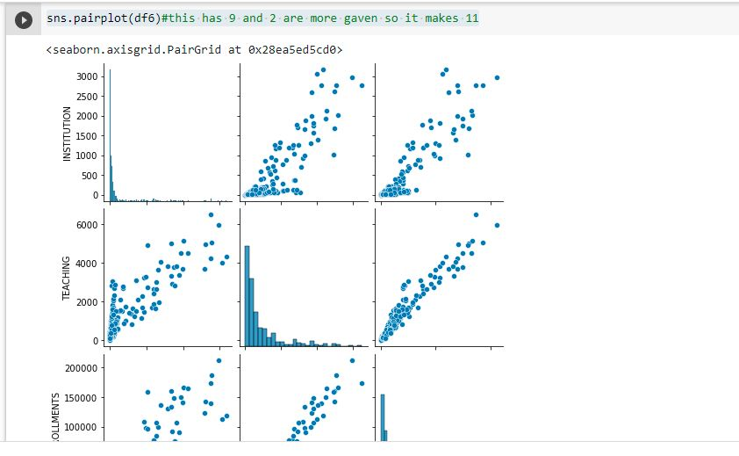

sns.jointplot(x = df6['INSTITUTION'], y = df6['ENROLLMENTS'], kind = 'scatter')

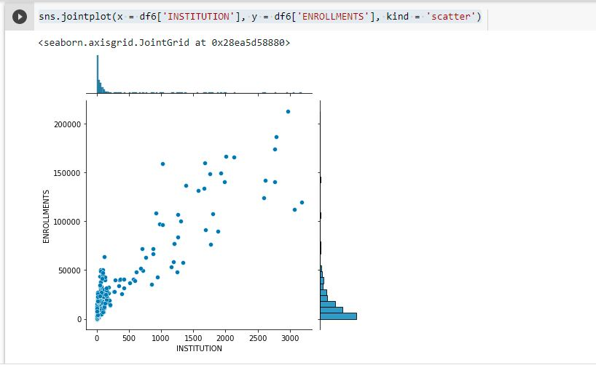

sns.distplot(x = df6['TEACHING'], bins = 10)

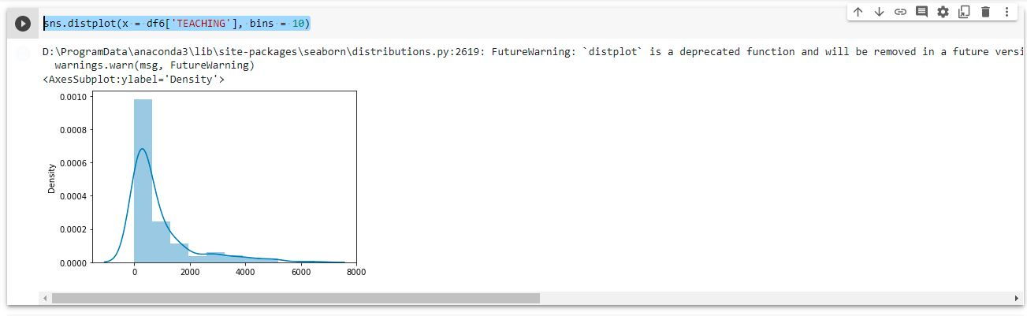

from sklearn import linear_model

lr= linear_model.LinearRegression()

X=df6.iloc[:,2].values.reshape(-1,1)

Y=df6.iloc[:,3].values.reshape(-1,1)

lr.fit(X,Y)

a = lr.predict([[200]])

a

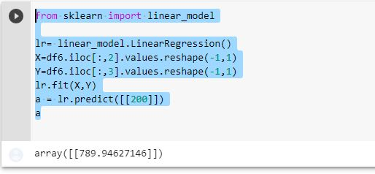

# Multi Regression

X=df6.drop(['District','Location','TEACHING'],axis=1)

Y=df6['TEACHING']

lr.fit(X,Y)



c=lr.intercept_

c

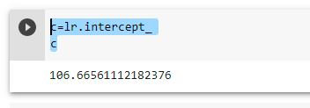

m=lr.coef_

m

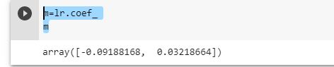

result=lr.predict(X)

result

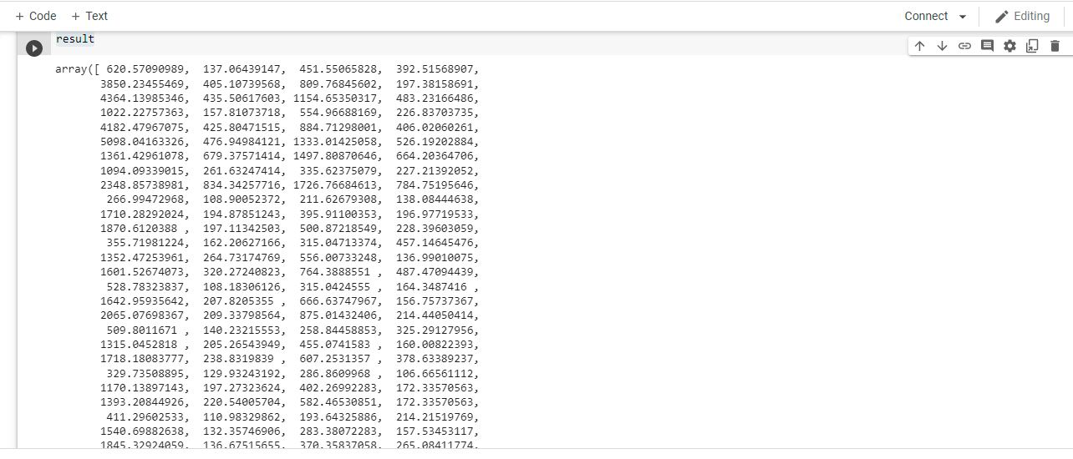

# Decision-Tree Regression

from sklearn.tree import DecisionTreeRegressor

Tree=DecisionTreeRegressor(max_depth=4,min_samples_leaf=0.1,random_state=3)

Tree.fit(X,Y)

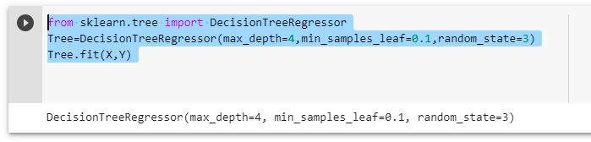

Predict=Tree.predict(X)

Predict

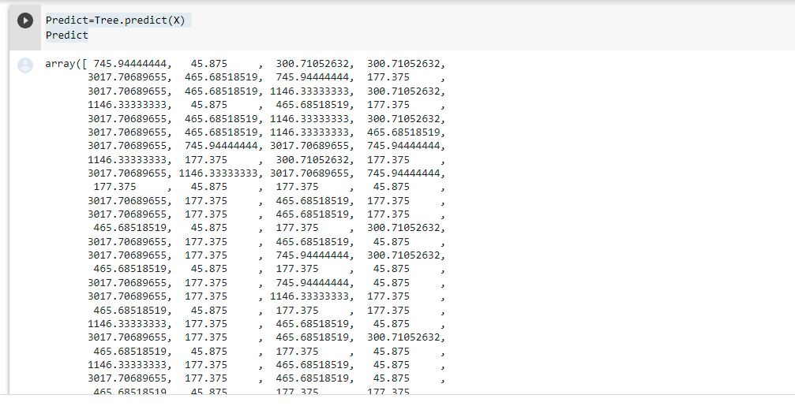

# RandomForestRegressor

from sklearn.ensemble import RandomForestRegressor

x= X.iloc [:, : -1]

y= Y.iloc [:]

regressor = RandomForestRegressor(n_estimators = 100, random_state = 0)

regressor.fit(x, y)

Y_pred = regressor.predict(np.array([6.5]).reshape(1, 1))

Y_pred

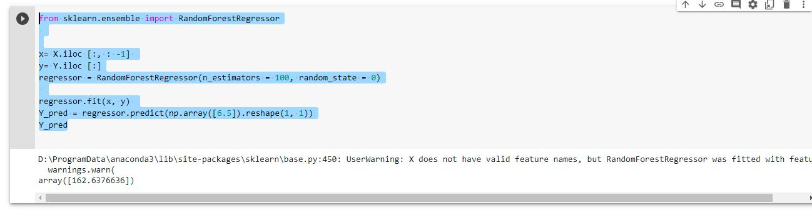

# SVM

from sklearn.svm import SVR

svm = SVR().fit(X, Y)

svm

result_value = svm.predict(X)

result_value

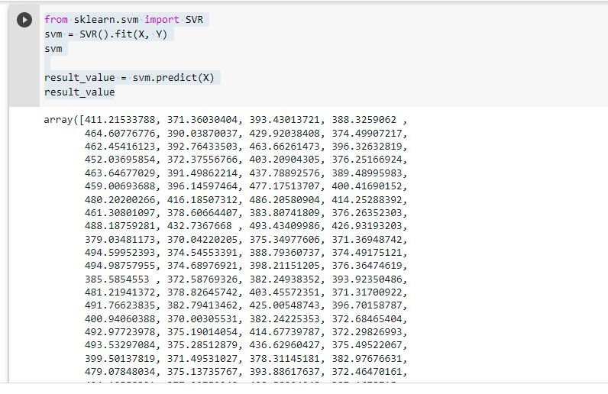

# Confusion Matrix plot_confusion_matrix only supports classifiers So I am make an random data set

from sklearn.datasets import make_classification

from sklearn.metrics import plot_confusion_matrix

from sklearn.model_selection import train_test_split

from sklearn.svm import SVC

X, y = make_classification(random_state=0)

X_train, X_test, y_train, y_test = train_test_split(X, y, random_state=0)

clf = SVC(random_state=0)

clf.fit(X_train, y_train)

SVC(random_state=0)

plot_confusion_matrix(clf, X_test, y_test)

plt.show()

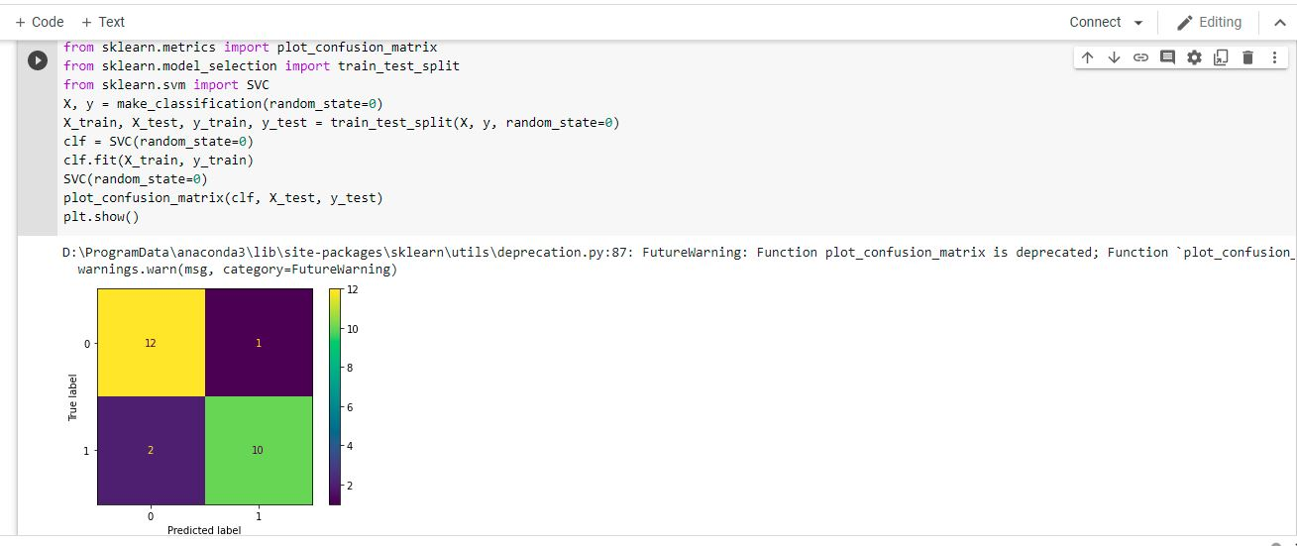

ROC AUC

An ROC curve shows the TPR as a function of FPR. Neither of these measures exists in the context of regression, so there is no such thing as ROC curves for regression.

# SVC AND LOGISTIC REGRESSION

from sklearn.metrics import roc_curve, auc

from sklearn.svm import SVC

from sklearn.linear_model import LogisticRegression

model_logistic = LogisticRegression()

model_logistic.fit(X_train, y_train)

y_pred_logistic = model_logistic.decision_function(X_test)

model_SVC = SVC(kernel = 'rbf', random_state = 4)

model_SVC.fit(X_train, y_train)

y_pred_svm = model_SVC.decision_function(X_test)

logistic_fpr, logistic_tpr, threshold = roc_curve(y_test, y_pred_logistic)

auc_logistic = auc(logistic_fpr, logistic_tpr)

svm_fpr, svm_tpr, threshold = roc_curve(y_test, y_pred_svm)

auc_svm = auc(svm_fpr, svm_tpr)

plt.figure(figsize=(5, 5), dpi=100)

plt.plot(svm_fpr, svm_tpr, linestyle='-', label='SVM (auc = %0.3f)' % auc_svm)

plt.plot(logistic_fpr, logistic_tpr, marker='.', label='Logistic (auc = %0.3f)' % auc_logistic)

plt.xlabel('False Positive Rate -->')

plt.ylabel('True Positive Rate -->')

plt.legend()

plt.show()

